Locarla Property Insight
Following feedback from a small focus group, we’ve decided to rename our RAG (Retrieval-Augmented Generation) tool to Locarla Property Insight. The general reaction was that no one had a scooby what “RAG” meant, which told us everything we needed to know.
For those who don’t know, two years ago we started building our own Q&A machine, something that works like ChatGPT, Gemini or Claude, but instead of searching the web, it searches Locarla data only. That means 507,000,000 data points covering England and Wales’ Social Housing Property, EPC and Deprivation metrics.
Because we couldn’t find anyone who had done this before, we had to figure it out ourselves. Hence the two-year timeline.
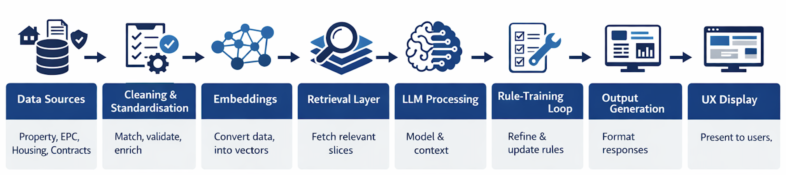
How to train your dRAGon
There’s not much for me to do during the R&D and build phase. Machine Learning, vector databases, Python, embeddings - I’m not a programmer and that work sits firmly in the back end, where I dare not tread.
The second stage is where I do come in. Training the RAG is where my strengths lie.
Think about the rules of football. They didn’t appear fully formed. They evolved over years of trial, error and refinement with one purpose: a consistent game everyone can follow.
It’s the same for LLM’s. We need to introduce a set of shared standards, or universal rulebook, that includes:
• Definitions
• Policies
• Logic
• Behavioural expectations
• Intent mapping
• Formatting rules
• Error handling
Then you have club-level rules. Every club has its own variations layered on top. No two clubs run things exactly the same way.
RAG development is identical. There are no pre-set rules. We have to write them all from scratch… with LLM support, but no shortcuts.
The rules of the game
These are rules every model must follow.
If a user says “as above, as before, expand on that, same again,” the system should treat that as an instruction to reuse the previous output.
If someone uses referential language - “that, those, it, them” - the model should check the previous answer before responding.
The rules of the club
These are rules that apply only to our dataset.
Example: some properties have no EPC. “No EPC” is a valid category. It must be counted explicitly.
And this is the stage we’re in now — and yes, this part can take another 12–18 months. The reasons are straightforward:
• Land Registry, EPC, Contract and Housing datasets are huge, messy, and full of quirks.
• We are aiming for accuracy, not giant-model guesswork.
• That means enforcing strict interpretive rules.
• We are mapping natural language → structured queries → correct data → clean narrative.
• What we’re building is a universal system that works for Locarla and, eventually, for housing associations’ internal data.
Roughly 60–70% of the work we’re doing now is directly transferable if we build a RAG for an individual housing provider.
You can help
If you work in Decarbonisation, Retrofit or EPC, we would really appreciate your test prompts – any questions you think will test our system. We’re data people. We can push the RAG in structured ways, but we don’t know enough to test expert-level questions properly.
Responses that come back unable to answer the question, or ‘don’t look right’ are not “wrong”, it just means we haven’t trained that behaviour yet.

Example test prompt
Prompt:
Retrieve Dataset A: All homes owned by Riverside. Return UPRN, building_id, easting/northing coordinates, full address.
Retrieve Dataset B: All homes owned by Platform Housing Group. Return UPRN, building_id, easting/northing coordinates, full address.
Adjacency Test:
For every Riverside home:
– Mark as same building if building_id also appears in Dataset B.
– Mark as next door if any Platform home is within 3 metres based on geospatial coordinates.
Calculate:
• total_riverside_owned
• riverside_adjacent_or_same_building
• percentage = (adjacent_or_same_building / total_riverside_owned) × 100
Return a factual result only based on retrieved rows. If retrieved_rows < 20 or total = 0, respond: “Insufficient data to determine adjacency.”
Yours do not have to look like this. This is simply to show the level of complexity we’re training for. And I’ll tell you a secret, I didn’t write the above prompt …
“ChatGPT – I am writing a prompt for a RAG application trained on Social Housing Property, EPC and Deprivation data for England and Wales. My prompt relates to: [insert topic].
Please format my prompt so the RAG has the best possible chance of producing an accurate response.”
The End.

